Design and Implementation of an Educational Industrial IoT Platform Using an SBC, an MCU, and a PLC
Patthanan Bhundhumani
Department of Electrical and Computer Engineering, Faculty of Engineering
King Mongkut's University of Technology North Bangkok
Advisor: Dr. Rawat Siripokarpirom

Abstract—This article presents a low-cost educational Industrial Internet of Things (IIoT) platform that integrates the three controller classes used in modern automation: a microcontroller (MCU, ESP32-S3), a single-board computer (SBC, Raspberry Pi 4), and a programmable logic controller (PLC, Siemens LOGO! 24CE). The MCU implements a Modbus RTU-to-TCP/MQTT gateway; eight open-source ESP32 Modbus gateway libraries were benchmarked on identical hardware to select an implementation, which was then measured for latency, throughput, and flash/RAM usage. Open-source software (Mosquitto, the Telegraf-InfluxDB-Grafana stack, Node-RED) carries the IT and edge layers, contrasted with the proprietary toolchain the PLC requires. A passive sniffer decodes Modbus TCP and MQTT on the wire, giving learners direct visibility into protocol behaviour. Results show that a single sub-2,000-THB microcontroller bridges legacy serial OT to an IT dashboard within its firmware budget, and that the three controller classes serve complementary, not competing, roles as teaching subjects.
Index Terms—Industrial IoT, Modbus gateway, IT/OT convergence, ESP32, programmable logic controller.
I. INTRODUCTION
Industry 4.0 pushes factories to expose shop-floor data to information-technology (IT) systems for monitoring, analytics, and remote supervision, yet the operational-technology (OT) equipment that runs physical processes still speaks decades-old protocols. Modbus, introduced in 1979, remains one of the most widely deployed field protocols; in its serial RTU form it runs over RS-485 with no native path to an IP network [4]. Replacing legacy OT hardware wholesale is rarely economic, so the practical problem is integration: lifting legacy OT signals into modern IT dashboards at low cost without compromising the determinism OT depends on. Three classes of controller dominate this landscape — the microcontroller (MCU), the single-board computer (SBC), and the programmable logic controller (PLC) — and a student entering the field must understand all three, including a divide this work treats as a first-class concern: the MCU and SBC are programmed with well-known open-source software, while the PLC is tied to a proprietary vendor toolchain.
Teaching IT/OT integration well requires hardware a student can touch, break, and instrument, but commercial IIoT trainers are expensive and closed, hiding the wire-level behaviour a learner needs to see. Two gaps follow: no low-cost bench exposes all three controller classes and real industrial protocols together, and although many open-source ESP32 Modbus gateway libraries exist, no empirical comparison guides which to use.
This work therefore (1) designs and builds a low-cost educational IIoT platform integrating an SBC (Raspberry Pi 4), an MCU (ESP32-S3), and a PLC (Siemens LOGO! 24CE); (2) demonstrates IT/OT integration using the open-source stack most common in IIoT practice — the MQTT broker Mosquitto, Node-RED, and the Telegraf-InfluxDB-Grafana (TIG) stack; (3) implements a Modbus RTU-to-TCP/MQTT gateway on the MCU, benchmarking open-source ESP32 Modbus libraries to select one and measuring its latency, throughput, and flash/RAM footprint; and (4) develops an IoT-Sniffer that decodes Modbus TCP and MQTT to observe network activity and measure device-level network performance.
The remainder of this paper is organised as follows. Section II reviews IT/OT convergence and the automation pyramid, formalises the Modbus RTU and TCP framings and the MQTT delivery model that the gateway bridges, and situates the three controller classes and the related literature against the two gaps this work targets. Section III describes the platform's overall architecture, the hardware selected for each controller class, the software layers running on each device, the performance metrics used throughout the evaluation, and the data model behind the telemetry dashboard. Section IV reports the Modbus library benchmark and the production gateway's measured resource footprint and cycle time. Section V discusses the three controller classes' complementary roles, a cost-per-channel comparison, the limitations of the present evaluation, practical obstacles encountered during development, and directions for future work, before concluding.
II. BACKGROUND AND RELATED WORK
A. IT/OT Convergence and the Automation Pyramid
Industrial automation has historically separated two domains: operational technology (OT), comprising the controllers, sensors, and actuators that drive physical processes and prizes determinism, availability, and safety; and information technology (IT), comprising the servers, databases, and dashboards that store and present data and prizes throughput, flexibility, and confidentiality. The ISA-95 enterprise-control model [3] formalises this separation as a five-level pyramid: Level 0 (the physical process), Level 1 (sensing and manipulation, e.g. RTU field instruments), Level 2 (supervisory control, e.g. the PLC scan cycle), Level 3 (site operations and historian data), and Level 4 (enterprise resource planning). Classic automation confines Levels 0-2 to isolated serial fieldbuses; Industry 4.0 demands that Level 0-2 data reach Level 3-4 systems in real time — IT/OT convergence [1], [2]. The gateway built in this work sits precisely at the Level 2/Level 3 boundary, translating a Level-1/2 fieldbus protocol (Modbus RTU) into the transport (TCP) and messaging (MQTT) protocols Level 3/4 systems expect.
B. Modbus Protocol Fundamentals
Modbus RTU is a request-response, master-slave protocol in which a single master polls one or more serial slaves over RS-485 [4]. Each RTU frame is a compact byte sequence:
$$Frame = Addr ∣ FC ∣ Data ∣ CRC-16$$ (1)
where Addr is a single byte holding the slave address in the range 1-247 (0 is reserved as the broadcast address), FC is a one-byte function code (e.g. 0x03 read holding registers, 0x06 write single register, 0x10 write multiple registers), Data is a variable-length payload of up to 252 bytes carrying the register addresses, counts, and values relevant to that function code, and CRC-16 is a two-byte cyclic redundancy check computed over every preceding byte, letting a receiver discard a corrupted frame without waiting for a higher-layer timeout. Because RTU is a serial protocol, the theoretical minimum time to transmit N one-byte characters at a given baud rate follows directly from the UART framing (1 start bit + 8 data bits + 1 stop bit, no parity, as configured here):
$$t_{wire} = \frac{10 × N_{chars}}{baud}$$ (2)
For the 9,600-baud link and the roughly 23-character frames exchanged in the FC03 benchmark of Section IV-A, (2) evaluates to approximately 24 ms per transaction — the wire-time floor against which the measured 27.7-33.4 ms means in Table I are compared; the difference is inter-frame turnaround and library-side processing, not the serial link itself. Modbus TCP carries the same protocol data unit over TCP port 502 with a seven-byte MBAP (Modbus Application Protocol) header replacing the serial address and CRC:
$$MBAP = TxID ∣ ProtoID ∣ Len ∣ UnitID$$ (3)
TxID is a two-byte transaction identifier that lets a client match asynchronous responses to the requests that triggered them, ProtoID is a two-byte field always zero for Modbus, Len is a two-byte count of the bytes remaining in the message after this field, and UnitID is a one-byte address of a sub-device behind a gateway — the field the ESP32-S3 and the LOGO! 24CE both expose so that either can be polled as if it were a native Modbus TCP server. Because a device that implements both framings can relay one into the other with only a header rewrite and a checksum recomputation, RTU-to-TCP gateways such as the one built here are, at the protocol level, a comparatively small piece of firmware, which is part of why an inexpensive MCU can host one without difficulty.
C. MQTT Publish-Subscribe Model
MQTT is a lightweight publish-subscribe protocol (ISO/IEC 20922) [5] in which clients publish messages to named broker topics and other clients subscribe to receive them, decoupling producers from consumers in time, space, and synchronisation. Delivery is governed by one of three quality-of-service (QoS) levels: QoS 0 delivers at most once, with no acknowledgement and no retransmission; QoS 1 delivers at least once, with the sender retransmitting until a PUBACK is received, which can duplicate messages; and QoS 2 delivers exactly once, using a four-part handshake at the cost of additional round trips. The gateway publishes sensor readings at QoS 1, trading the small possibility of a duplicate JSON payload for a guarantee that no reading silently disappears — an appropriate choice for a telemetry stream where a duplicate sample is harmless but a lost one degrades the dashboard.
D. Programmable Device Classes
Three classes of programmable device span modern automation. The MCU integrates a processor, memory, and peripherals on one chip; the ESP32-S3 used here runs the Arduino core over FreeRTOS and is a natural low-cost protocol-conversion node, though flash and RAM are scarce and must be measured. The SBC runs a full operating system on commodity hardware — the Raspberry Pi 4 hosts the data-plane services in Docker — trading the MCU's determinism for general-purpose flexibility. The PLC executes a fixed scan cycle and is programmed in one of the five IEC 61131-3 languages (ladder diagram, function block diagram, structured text, instruction list, and sequential function chart); the Siemens LOGO! 24CE contributes certified industrial I/O and a native Modbus TCP server but is programmed only through the proprietary LOGO! Soft Comfort, which exposes solely its ladder-style function-block editor. This openness divide — open-source Arduino/Linux tooling for the MCU and SBC versus a closed vendor toolchain for the PLC — lets students experience vendor lock-in directly rather than as an abstraction.
E. Related Work and Identified Gaps
Prior work has built ESP32-based Modbus gateways and IoT testbeds, and surveys of IIoT protocols recur around the same small set of open-source tools: an MQTT broker, Node-RED, and the TIG stack [1]-[8]. This work adopts that de-facto stack rather than inventing bespoke components. Two gaps remain, however: existing testbeds typically demonstrate one controller class rather than integrating the MCU, SBC, and PLC together, and no published benchmark compares open-source ESP32 Modbus libraries on identical hardware. This work addresses both.
III. SYSTEM DESIGN AND IMPLEMENTATION
A. Overall Architecture
The platform integrates the three controller classes on a single local-area network (Fig. 1). Field instruments — an XY-MD02 temperature/humidity sensor and an Eastron SDM230 power meter — are Modbus RTU slaves on an RS-485 bus. The Siemens LOGO! 24CE performs deterministic control with industrial I/O. The ESP32-S3 edge gateway converts protocols, and the Raspberry Pi 4 hosts the MQTT broker and the TIG data plane. Two data paths result: Path A is direct Modbus TCP, where any LAN host, including the PLC acting as master, polls a Modbus TCP server; Path B is the telemetry pipeline, where the ESP32-S3 polls the RTU sensors, publishes JSON over MQTT, and Telegraf ingests it into InfluxDB for display in Grafana.
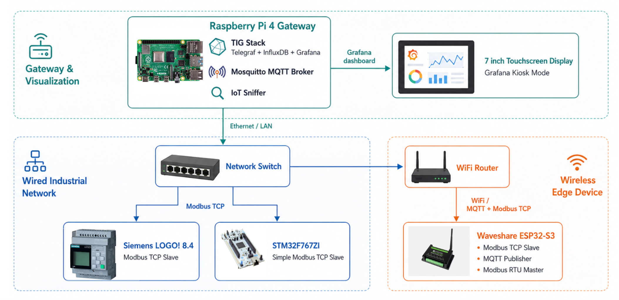
Fig. 1. Overall platform architecture and data paths.
B. Hardware Selection
Hardware was chosen to cover all three controller classes at lowest cost while using real industrial signalling. The MCU is a Waveshare ESP32-S3-Relay-6CH (~1,895 THB), chosen for its on-board RS-485 transceiver, six relay outputs, and PlatformIO support. The SBC is a Raspberry Pi 4 (2 GB), chosen for Linux, Docker, and Ethernet. The PLC is a Siemens LOGO! 24CE (part 6ED1052-1CC08-0BA2), a 24 V DC unit with four transistor outputs and a native Modbus TCP server. The field instruments were chosen as inexpensive Modbus RTU slaves that nonetheless expose real measurement semantics, including the IEEE-754 float pairs of the power meter.
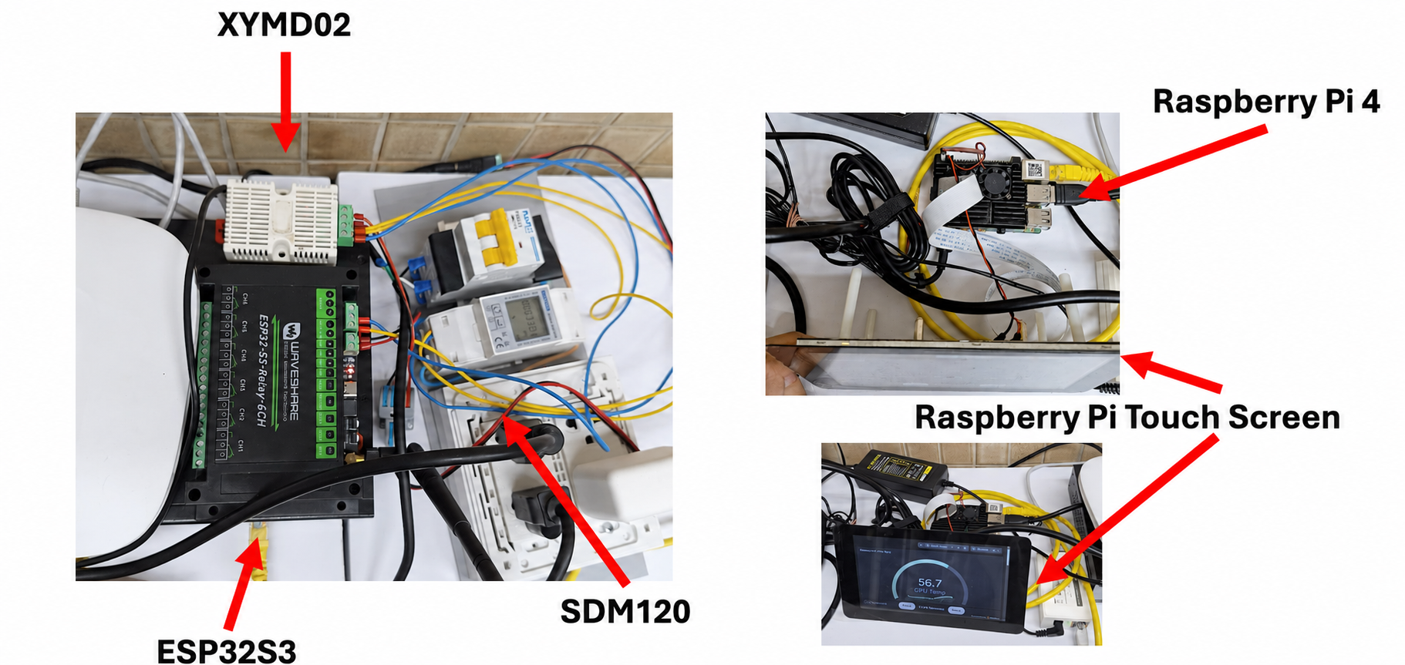
Fig. 2. Physical hardware setup on the laboratory bench.
C. Software Layers
The LOGO! 24CE is programmed exclusively through LOGO! Soft Comfort; a representative program implements a self-latching start/stop with a runtime counter, and its Modbus TCP server exposes discrete and analogue points as coils and V-memory words readable by any LAN host.
The ESP32-S3 firmware is an Arduino-core, PlatformIO application running a single cooperative, non-blocking loop on a two-second cycle. It performs three concurrent roles: a hand-rolled Modbus RTU master polling the two sensors over RS-485; an MQTT publisher (256dpi/MQTT) sending readings as JSON at QoS 1, omitting faulty fields rather than fabricating values; and a Modbus TCP slave (emelianov/modbus-esp8266) serving the same readings on port 502 as holding registers HR0-HR20. The build occupies 946 KB of the 1,310 KB application partition (72.2%) and 48.5 KB of 327.6 KB RAM (14.8%).
The Raspberry Pi hosts the IT layer as Docker Compose services: Mosquitto 2.0 (MQTT broker), InfluxDB 2.7 (time-series storage), Telegraf 1.28 (bridging MQTT to InfluxDB and collecting host metrics), and Grafana (dashboards, with an anonymous kiosk viewer role). Because every component is declared in one Compose file with pinned tags, the entire IT layer is reproducible by a student on commodity hardware.
A passive IoT-Sniffer, written in Python with scapy's AsyncSniffer, decodes Modbus TCP and MQTT frames on the wire, computes live throughput and p50/p95/p99 latency, and pushes decoded frames to a browser dashboard over WebSocket — giving learners a live, readable view of every frame the platform exchanges and serving as an independent check on protocol correctness during development.
D. Performance Metrics and Measurement Methodology
Three quantities recur throughout Section IV and are defined precisely here so that the benchmark in Section IV-A and the production figures in Section IV-B are directly comparable. Round-trip latency for a single transaction is the wall-clock interval between the client issuing a request and receiving the corresponding response:
$$L_{i} = t_{response,i} − t_{request,i}$$ (4)
Because a fixed number of such transactions is repeated per test run, the sample is summarised with percentiles rather than the mean alone, since mean latency hides tail behaviour that matters for a real-time gateway. The p-th percentile is the smallest observed value L such that at least p percent of the N samples are less than or equal to it:
$$p_{95} = L_{⌈0.95×N⌉}, for L sorted ascending$$ (5)
with p50 and p99 defined analogously; a single slow outlier (such as the 132 ms sample recorded for zivillian/eModbus) shifts p99 sharply while leaving the mean and p50 comparatively unaffected, which is why Section IV-A reports the outlier explicitly rather than relying on the mean column of Table I alone. Throughput is the number of completed transactions per unit time over an observation window T:
$$Throughput = \frac{N_{transactions}}{T}$$ (6)
Finally, firmware resource utilisation is reported as a simple percentage of the partition or memory region available on the target:
$$Util(\%) = \frac{{Bytes}_{used}}{{Bytes}_{available}} × 100$$ (7)
applied in Section III-C and Section IV-B to the 1,310 KB application partition and the 327.6 KB RAM region of the ESP32-S3-Relay-6CH.
E. Data Model, Storage, and Visualisation
The telemetry pipeline's data model follows the shape of InfluxDB's line protocol, in which every point is a measurement name, a set of indexed tags, a set of numeric fields, and a timestamp. Telegraf's MQTT consumer input subscribes to the sensor topics, parses the incoming JSON payload, and maps it onto this model: the measurement name identifies the sensor class (e.g. power_meter or temp_humidity), tags carry low-cardinality metadata such as the device ID and location that a user is likely to filter or group by, and fields carry the numeric readings themselves — voltage, current, active power, and energy for the SDM230, and temperature and relative humidity for the XY-MD02. Keeping identifying metadata in tags rather than fields matters for query performance, since InfluxDB indexes tags but not fields, so a dashboard panel that groups readings by device benefits from this separation even at the platform's modest data rate.
Grafana reads directly from InfluxDB using Flux queries and renders three panel types across the default dashboard: time-series panels for the continuous voltage, current, and power traces; gauge panels for the instantaneous temperature and humidity readings, thresholded against comfortable-range bands so a learner can see an out-of-range condition at a glance; and a table panel listing the most recent value of every registered point alongside its last-update timestamp, which doubles as a simple liveness check — a stale timestamp indicates the RTU poll or the MQTT publish has stalled before any alerting rule fires. The dashboard is also exposed through Grafana's anonymous kiosk viewer role so that it can be shown on the touchscreen bench display without requiring every student to hold a login, while write access to InfluxDB and to the underlying Docker host remains authenticated.
Because Telegraf, InfluxDB, and Grafana are all declared with pinned image tags in the same Docker Compose file introduced in Section III-C, the entire data model — measurement names, tag keys, retention policy, and dashboard JSON — is version-controlled alongside the code that produces it, so a student can reset the whole IT layer to a known state by tearing down and recreating the containers rather than by manually reconfiguring three separate applications.
IV. EVALUATION AND RESULTS
A. Modbus Gateway Library Benchmark
Eight open-source ESP32 Modbus gateway libraries were evaluated on an identical ESP32-S3-DevKitC-1 with a MAX3485 transceiver, against a host PC running pymodbus as a simultaneous Modbus TCP client and RTU slave (9,600 baud, 8-N-1). Round-trip latency was measured over a four-step FC03/FC06/FC03/FC16 transaction (theoretical wire-time floor ≈ 24 ms); flash and RAM were taken from the build; and a stress suite injected bad CRCs, a slow-slave delay, a TCP reset, and a Wi-Fi drop. Table I summarises the results.

TABLE I
FC03 Round-Trip Latency and Resource Usage per Modbus Library (ESP32-S3, 100 Registers, 9,600 Baud)
Library | Framework | Mean  (ms) | Flash  (KB) | RAM  (KB) | Stress
tobiasfaust | Arduino | 27.7 | 300 | 22.0 | Pass
vwetter | Arduino | 27.9 | 301 | 22.0 | Pass
harihanv | Arduino | 28.0 | 300 | 22.0 | Pass
maxx-ukoo/esp-modbus | ESP-IDF | 27.8 | 270 | 14.4 | Pass
espressif/esp-modbus | ESP-IDF | 28.0 | 270 | 14.4 | Pass
eModbus/eModbus | Arduino | 30.3 | 384 | 22.9 | Pass
zivillian/eModbus | Arduino | 32.9 | 384 | 22.9 | Pass
emelianov/modbus-esp8266 | Arduino | 33.4 | 310 | 22.2 | Pass (rec.)

All eight libraries passed the stress suite. The fastest on mean latency is tobiasfaust (27.7 ms); the ESP-IDF libraries approach wire speed with the smallest RAM footprint (14.4 KB); the asynchronous Arduino libraries add roughly 2 ms per step, and zivillian showed a single 132 ms outlier; emelianov/modbus-esp8266 is slowest on mean latency (33.4 ms) but was ultimately recommended, because latency differences of a few milliseconds are immaterial against the platform's two-second telemetry cycle, while it is the only actively maintained library that simultaneously provides RTU master, Modbus TCP slave, and multi-client TCP roles, with the smallest combined binary (310 KB) among TCP-capable libraries.
B. Gateway Performance
The production gateway runs the chosen library as a Modbus TCP slave alongside the RTU master, MQTT publisher, and watchdog, all from one cooperative loop. It occupies 946 KB of the 1,310 KB application partition (72.2%) and 48.5 KB of 327.6 KB RAM (14.8%), and completes a full sensor-poll-publish-serve cycle well inside the two-second budget, confirming that a complete dual-protocol gateway fits a low-cost MCU with substantial headroom.
V. DISCUSSION AND CONCLUSION
The platform confirms that a single low-cost microcontroller can bridge legacy serial OT equipment to a modern IT dashboard within its firmware budget. Table II compares the three controller classes: each occupies a distinct, complementary role rather than competing with the others.

TABLE II
Comparison of the Three Controller Classes Used in the Platform
Attribute | MCU  ESP32-S3 | SBC  RPi 4 | PLC  LOGO! 24CE
Operating system | None (cooperative loop) | Full Linux | Proprietary firmware
Determinism | Soft real-time | Non-deterministic | Hard real-time
Networking | Wi-Fi / BLE | Gigabit Ethernet | 10/100 Modbus TCP
Toolchain | Open (Arduino/PlatformIO) | Open (Linux/Docker) | Proprietary (Soft Comfort)
Certification | None | None | CE, UL, FM, ATEX
Approx. unit cost | ~1,895 THB | ~1,900-3,200 THB | ~5,000-6,500 THB

The MCU delivers the lowest cost-per-channel and lowest power and is the correct field-edge gateway, but lacks an operating system and certification. The SBC offers unmatched software richness — any Linux package or container runs unmodified — but its preemptive scheduler cannot guarantee hard real-time behaviour, so it belongs in the data plane, not in control. The PLC alone drives mains-level actuators under a bounded, certified scan cycle — a safety property, not merely a performance figure — but is the most expensive and the most closed. The assignment of each device to its role is therefore an engineering consequence, not a preference.
A. Cost-Per-Channel Analysis
Table II reports unit cost, but a fairer comparison for a teaching bench normalises cost by the number of I/O channels a device actually exposes, since a controller that is cheap per unit but sparse in I/O is not necessarily cheap per point of control:
$$C_{channel} = \frac{C_{unit}}{N_{channels}}$$ (8)
Applying (8) to the six relay outputs of the Waveshare ESP32-S3-Relay-6CH gives C_channel ≈ 1,895 / 6 ≈ 316 THB per channel. The Siemens LOGO! 24CE exposes four transistor outputs, so C_channel ≈ 5,000-6,500 / 4 ≈ 1,250-1,625 THB per channel — four to five times the MCU's figure. This gap is not simply markup: it is priced-in certification (CE, UL, FM, ATEX), a hard real-time scan-cycle guarantee, and mains-adjacent electrical isolation, none of which the MCU provides. The SBC does not fit this formula cleanly, since Raspberry Pi GPIO is general-purpose rather than industrially rated, but its cost is more usefully normalised per software service hosted, where a single 2 GB unit ran five Docker containers concurrently (Section V-B) at effectively zero marginal hardware cost per additional service.
B. Limitations and Threats to Validity
Several limitations bound the conclusions above. First, the library benchmark in Section IV-A used a single hardware sample per library rather than multiple boards, so board-to-board variance in crystal tolerance or transceiver timing is not captured; the percentile methodology of Section III-D mitigates within-run variance but not this between-unit variance. Second, latency was measured over a wired RS-485 bus at a fixed 9,600 baud; Wi-Fi-side latency and jitter, which affect the MQTT publish path but not the FC03 benchmark itself, were not isolated from the wired measurement. Third, the 2 GB Raspberry Pi constrains the number of Docker services that can run comfortably, so the IT-layer results describe a lower memory tier and would understate headroom on the 4 GB or 8 GB variants. Fourth, the platform has been exercised by its developer and not yet by an independent cohort of students, so the educational-value claims in Section I are a design goal rather than a measured outcome; the trial proposed in Section V-D is intended to close this gap.
C. Practical Implementation Obstacles
Development surfaced several practical obstacles: selecting among numerous ESP32 Modbus libraries of uneven quality, resolved by the systematic benchmark of Section IV-A; intermittent CRC errors traced to RS-485 wiring, polarity, and grounding; memory pressure on the 2 GB Raspberry Pi from running five containers simultaneously, mitigated by a headless OS and continuous monitoring; and a Node-RED container that could not reach the gateway over Modbus TCP until it was folded into the same Docker Compose network as the other services. Each obstacle is recorded here rather than silently fixed because they are precisely the kind of integration friction a textbook omits and a student bringing up similar hardware for the first time should expect to encounter; the RS-485 wiring fault in particular reproduced intermittently and was only isolated by cross-checking the IoT-Sniffer's live frame view against an oscilloscope trace of the differential pair, underscoring the pedagogical value of the passive sniffer described in Section III-C beyond its role as a benchmarking tool.
D. Future Work
Future work should add a telemetry ring buffer and over-the-air updates to the gateway, scheduled backups and alerting to the IT layer, and OPC-UA support to broaden interoperability. The current MQTT broker and Modbus TCP server also accept unauthenticated connections on the laboratory LAN, which is acceptable for a teaching bench behind a firewall but should be hardened with TLS and per-client credentials before any deployment beyond the classroom. Finally, the platform should be trialled with a cohort of students to assess its educational value directly, replacing the design-goal claim of Section I with a measured outcome and addressing the limitation noted in Section V-B.
E. Conclusion
Overall, this work delivers a reproducible, sub-6,500-THB-per-device educational IIoT bench that integrates all three controller classes with real industrial protocols, together with an evidence-based Modbus library recommendation, a formalised cost-per-channel comparison, and a live protocol-visibility tool, filling both gaps identified in the literature.
ACKNOWLEDGMENT
The author thanks the Department of Electrical and Computer Engineering, Faculty of Engineering, King Mongkut's University of Technology North Bangkok, for laboratory access and bench space, and Dr. Rawat Siripokarpirom for guidance on the platform's scope and on the experimental design of the Modbus library benchmark reported in Section IV-A.
REFERENCES
[1] S. Santos, P. Costa, and A. Rocha, "IT/OT convergence in Industry 4.0: risks and analysis of the problems," in Proc. 18th Iberian Conf. Information Systems and Technologies (CISTI), 2023.
[2] L. D. Xu, E. L. Xu, and L. Li, "Industry 4.0: state of the art and future trends," Int. J. Prod. Res., vol. 56, no. 8, pp. 2941-2962, 2018.
[3] Enterprise-Control System Integration — Part 1: Models and Terminology, ISA-95.00.01, 2010.
[4] Modbus Organization, Modbus Application Protocol Specification V1.1b3, 2012.
[5] Information Technology — Message Queuing Telemetry Transport (MQTT) v3.1.1, ISO/IEC 20922, 2016.
[6] InfluxData, "Telegraf 1.28 documentation," 2024. [Online]. Available: https://docs.influxdata.com/telegraf/.
[7] InfluxData, "InfluxDB 2.7 documentation," 2024. [Online]. Available: https://docs.influxdata.com/influxdb/v2/.
[8] Grafana Labs, "Grafana documentation," 2024. [Online]. Available: https://grafana.com/docs/grafana/latest/.

